**REST - Get country based on country code** 

**CountryService.java:**

**package** com.cognizant.spring_learn.service;

**import** com.cognizant.spring_learn.Country;

**import** org.springframework.stereotype.Service;

**import** org.springframework.context.ApplicationContext;

**import** org.springframework.context.support.ClassPathXmlApplicationContext;

**import** java.util.List;

**import** java.util.Optional;

@Service

**public** **class** CountryService {

**public** Country getCountry(String code) {

ApplicationContext context = **new** ClassPathXmlApplicationContext("country.xml");

List<Country> countryList = context.getBean("countryList", List.**class**);

Optional<Country> country = countryList.stream()

.filter(c -> c.getCode().equalsIgnoreCase(code))

.findFirst();

**return** country.orElse(**null**);

}

}

**CountryController.java:**

**package** com.cognizant.spring_learn.controller;

**import** com.cognizant.spring_learn.Country;

**import** com.cognizant.spring_learn.service.CountryService;

**import** org.slf4j.Logger;

**import** org.slf4j.LoggerFactory;

**import** org.springframework.beans.factory.annotation.Autowired;

**import** org.springframework.web.bind.annotation.GetMapping;

**import** org.springframework.web.bind.annotation.PathVariable;

**import** org.springframework.web.bind.annotation.RestController;

@RestController

**public** **class** CountryController {

**private** **static** **final** Logger ***LOGGER*** = LoggerFactory.*getLogger*(CountryController.**class**);

@Autowired

**private** CountryService countryService;

@GetMapping("/countries/{code}")

**public** Country getCountry(@PathVariable String code) {

***LOGGER***.debug("START - getCountry for code: {}", code);

Country country = countryService.getCountry(code);

***LOGGER***.debug("Country found: {}", country);

***LOGGER***.debug("END - getCountry");

**return** country;

}

}

**Country.java:**

**package** com.cognizant.spring_learn;

**public** **class** Country {

**private** String code;

**private** String name;

**public** Country() {}

**public** Country(String code, String name) {

**this**.code = code;

**this**.name = name;

}

**public** String getCode() { **return** code; }

**public** **void** setCode(String code) { **this**.code = code; }

**public** String getName() { **return** name; }

**public** **void** setName(String name) { **this**.name = name; }

@Override

**public** String toString() {

**return** "Country [code=" + code + ", name=" + name + "]";

}

}

**SpringLearnApplication.java:**

**package** com.cognizant.spring_learn;

**import** org.slf4j.Logger;

**import** org.slf4j.LoggerFactory;

**import** org.springframework.boot.SpringApplication;

**import** org.springframework.boot.autoconfigure.SpringBootApplication;

@SpringBootApplication

**public** **class** SpringLearnApplication {

**private** **static** **final** Logger ***LOGGER*** = LoggerFactory.*getLogger*(SpringLearnApplication.**class**);

**public** **static** **void** main(String[] args) {

***LOGGER***.info("Starting SpringLearnApplication...");

SpringApplication.*run*(SpringLearnApplication.**class**, args);

***LOGGER***.info("SpringLearnApplication started successfully.");

}

}

**OUTPUT:**

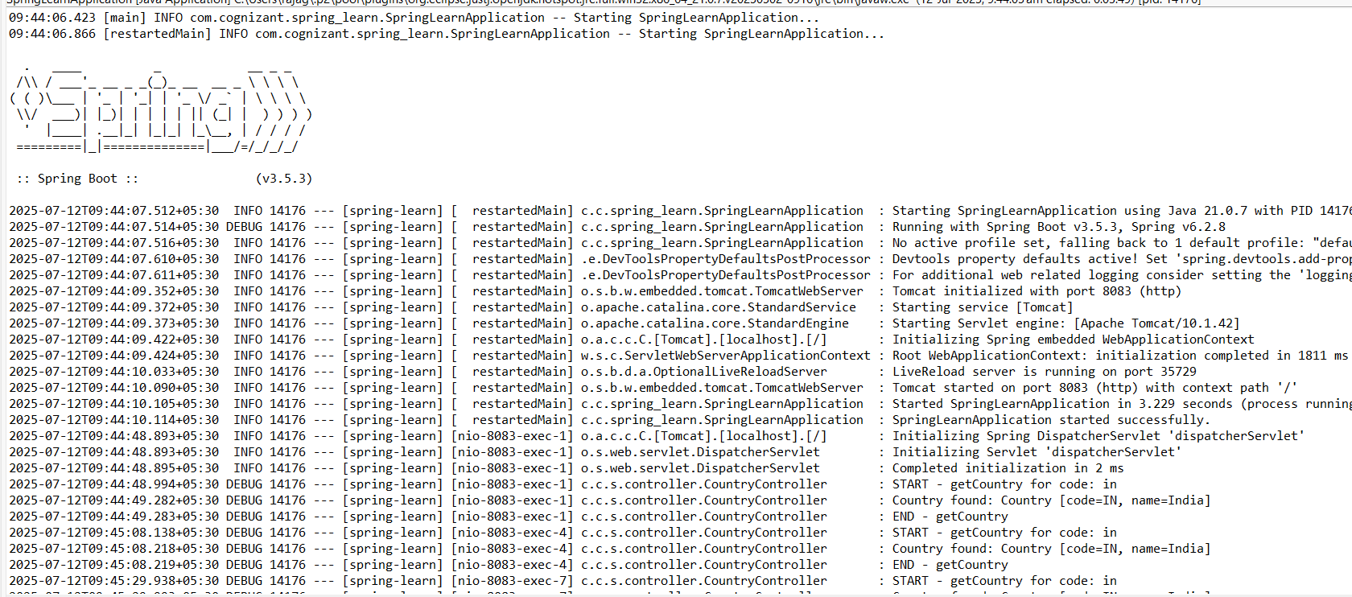

<http://localhost:8083/countries/in>

<http://localhost:8083/countries/IN>

<http://localhost:8083/countries/In>

